***BUG Report***

**These bugs are also reproduced by Cucumber+ Cypress**

**Bug 1**

**Steps to Reproduce**

1. Navigate to the application Technical assignment.
2. Check the system requirements description.
3. Check the **abbility**  and **digitalis** spelling in **Add asset section**.
4. Check the **abbility and assert** spelling in **Existing asset**

**Expected Result**

1. **abbility**  - should be **abbility**
2. **digitalis** should be **digits**
3. **Assert** shouldbe **asset**

**Actual Result**

The spelling of these 3 terms is incorrect as defined in Steps to reproduce. Please find the screenshot for reference.

Screenshot

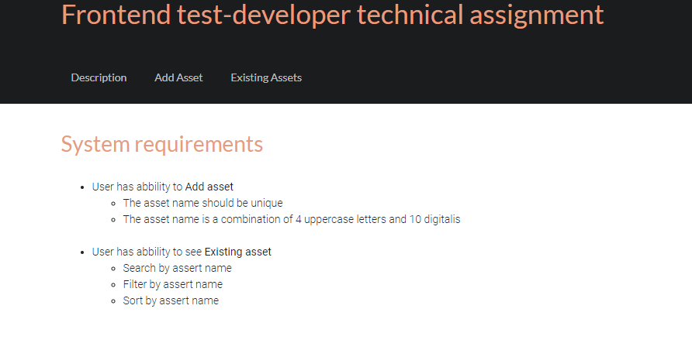

**Bug 2**

**Steps to Reproduce**

1. Navigate to the application Technical assignment.
2. Click on the Existing Assets tab
3. Check for the list of Existing assets

**Expected Result**

1. All the existing assets details should be visible.

**Actual Result**

The page keeps on loading and nothing is displayed on the UI. Please find the screenshot for reference.

